電通二乙微處理器實驗 實驗結報

實驗名稱 | Lab02-跑馬燈
組別 |  | 組員 | 丁瑜楷

- 實驗目的
利用Ardino 7697 的接腳接到LED，做出題目所規定跑馬燈
- 實驗步驟
實驗一 :
1.LED 向左及向右執行花色展示
實驗二 :
1.LED 向左及向右執行花色展示
2. 執行自定花色展示: 所有LED亮滅兩次 > 左移八次 > 所有LED亮滅兩次 > 右移八次
實驗三 :
1. Arduino 接上一個開關
2. 開關 OFF > LED 向左及向右執行花色展示
3. 開關 ON > 執行自定花色展示

- 程式碼

// Lab02_1
const byte startPin = 7;

const byte endPin = 14;
byte i;
byte n;
void setup()
{
// 將每個 Pin 設定成輸出
for (byte i = startPin; i<= endPin; i++)
{
pinMode(i, OUTPUT);
}
}

void loop()
{
for (i=startPin;i<=endPin;i++)
digitalWrite(i, LOW);

for (i=startPin;i<=endPin;i++)
digitalWrite(i, LOW);
for (i=endPin;i>=startPin;i--)
{

digitalWrite(i, HIGH);
delay(100);

digitalWrite(i, LOW );
delay(100);
}

for (i=startPin;i<=endPin;i++)
{

digitalWrite(i, HIGH);
delay(100);

digitalWrite(i, LOW );
delay(100);
}
}

// Lab02_2
const byte startPin = 7;

const byte endPin = 14;

byte i;

byte n;

void setup()

{

// 將每個 Pin 設定成輸出

for (byte i = startPin; i<= endPin; i++)

{

pinMode(i, OUTPUT);

}

}

void loop()

{

for (i=startPin;i<=endPin;i++)

digitalWrite(i, LOW);

//輛滅

digitalWrite(7, HIGH);
digitalWrite(8, HIGH);
digitalWrite(9, HIGH);
digitalWrite(10, HIGH);
digitalWrite(11, HIGH);
digitalWrite(12, HIGH);
digitalWrite(13, HIGH);
digitalWrite(14, HIGH);
delay(100);

digitalWrite(14, LOW);
digitalWrite(13, LOW);
digitalWrite(12, LOW);
digitalWrite(11, LOW);
digitalWrite(10, LOW);
digitalWrite(9, LOW);
digitalWrite(8, LOW);
digitalWrite(7, LOW);
delay(100);

//輛滅

digitalWrite(7, HIGH);
digitalWrite(8, HIGH);
digitalWrite(9, HIGH);
digitalWrite(10, HIGH);
digitalWrite(11, HIGH);
digitalWrite(12, HIGH);
digitalWrite(13, HIGH);
digitalWrite(14, HIGH);
delay(100);

digitalWrite(14, LOW);
digitalWrite(13, LOW);
digitalWrite(12, LOW);
digitalWrite(11, LOW);
digitalWrite(10, LOW);
digitalWrite(9, LOW);
digitalWrite(8, LOW);
digitalWrite(7, LOW);
delay(100);

//輛滅結束

for (i=startPin;i<=endPin;i++)

digitalWrite(i, LOW);

for (i=endPin;i>=startPin;i--)

{

digitalWrite(i, HIGH);

delay(100);

digitalWrite(i, LOW );

delay(100);

}

//輛滅

digitalWrite(7, HIGH);
digitalWrite(8, HIGH);
digitalWrite(9, HIGH);
digitalWrite(10, HIGH);
digitalWrite(11, HIGH);
digitalWrite(12, HIGH);
digitalWrite(13, HIGH);
digitalWrite(14, HIGH);
delay(100);

digitalWrite(14, LOW);
digitalWrite(13, LOW);
digitalWrite(12, LOW);
digitalWrite(11, LOW);
digitalWrite(10, LOW);
digitalWrite(9, LOW);
digitalWrite(8, LOW);
digitalWrite(7, LOW);
delay(100);

//輛滅

digitalWrite(7, HIGH);
digitalWrite(8, HIGH);
digitalWrite(9, HIGH);
digitalWrite(10, HIGH);
digitalWrite(11, HIGH);
digitalWrite(12, HIGH);
digitalWrite(13, HIGH);
digitalWrite(14, HIGH);
delay(100);

digitalWrite(14, LOW);
digitalWrite(13, LOW);
digitalWrite(12, LOW);
digitalWrite(11, LOW);
digitalWrite(10, LOW);
digitalWrite(9, LOW);
digitalWrite(8, LOW);
digitalWrite(7, LOW);
delay(100);

//輛滅結束

for (i=startPin;i<=endPin;i++)

{

digitalWrite(i, HIGH);

delay(100);

digitalWrite(i, LOW );

delay(100);

}

}

// Lab02_3
const byte startPin = 7;

const byte endPin = 14;
byte i;
byte n;
void setup()
{
// 將每個 Pin 設定成輸出
for (byte i = startPin; i<= endPin; i++)
{
pinMode(i, OUTPUT);
}
pinMode(6, INPUT);
}

void loop()
{
if(digitalRead(6))
{
for (i=startPin;i<=endPin;i++)
digitalWrite(i, LOW);

for (i=startPin;i<=endPin;i++)
digitalWrite(i, LOW);
for (i=endPin;i>=startPin;i--)
{

digitalWrite(i, HIGH);
delay(100);

digitalWrite(i, LOW );
delay(100);
}

for (i=startPin;i<=endPin;i++)
{

digitalWrite(i, HIGH);
delay(100);

digitalWrite(i, LOW );
delay(100);
}
}
else
{
//輛滅
digitalWrite(7, HIGH);
digitalWrite(8, HIGH);
digitalWrite(9, HIGH);
digitalWrite(10, HIGH);
digitalWrite(11, HIGH);
digitalWrite(12, HIGH);
digitalWrite(13, HIGH);
digitalWrite(14, HIGH);
delay(100);
digitalWrite(14, LOW);
digitalWrite(13, LOW);
digitalWrite(12, LOW);
digitalWrite(11, LOW);
digitalWrite(10, LOW);
digitalWrite(9, LOW);
digitalWrite(8, LOW);
digitalWrite(7, LOW);
delay(100); }
//輛滅結束

}

- 實驗結果及分析
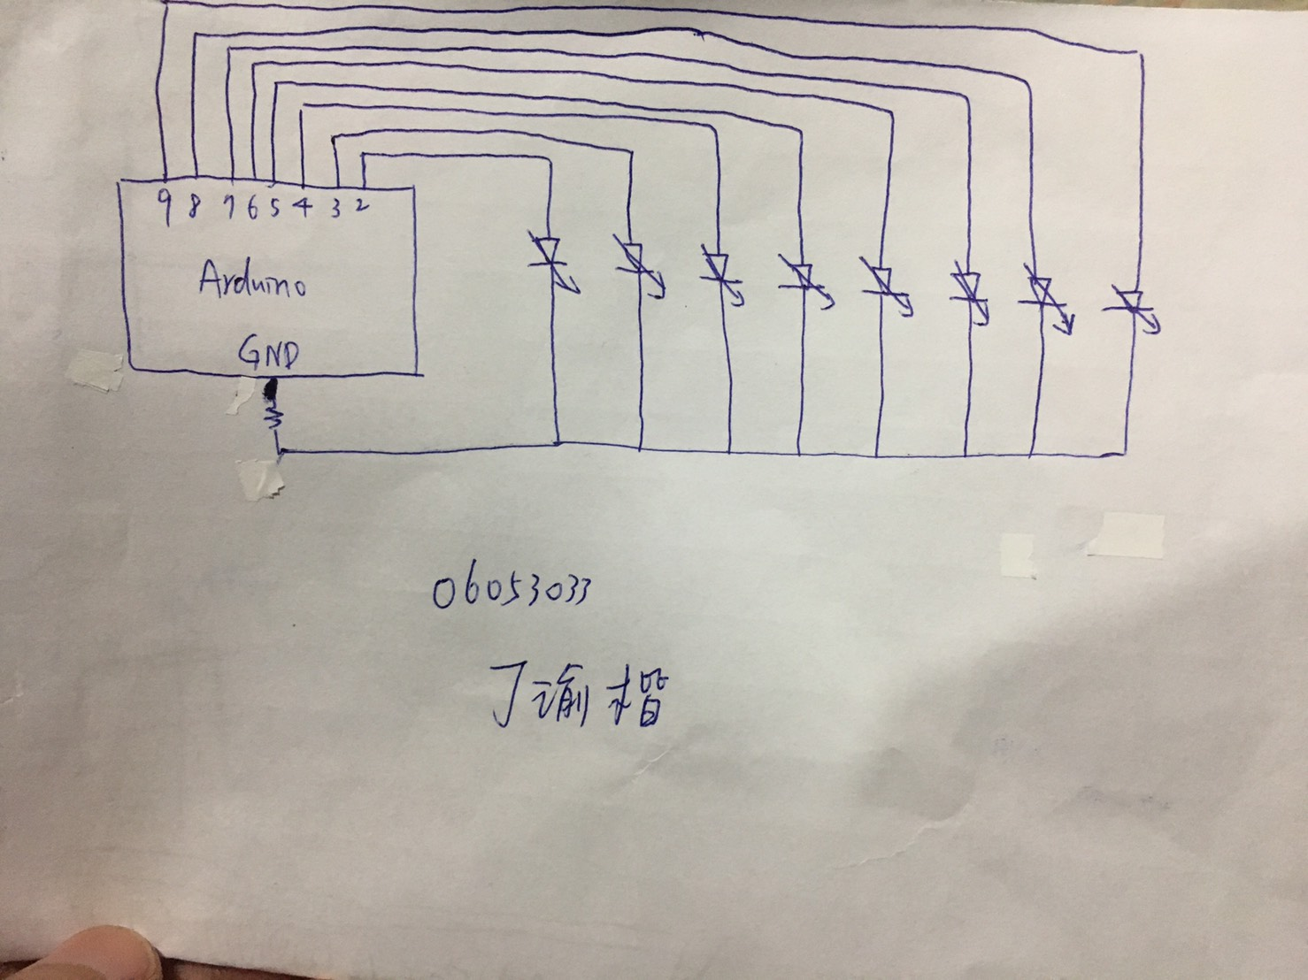
- 心得討論
這一次的實驗相對上一次的難度提升了許多,但經過大家的努力還是都完成了。

